4. SLIDING CONTACT BEARING
Bearing: Machine element which is used to support load by providing relative motion and by minimizing friction.
Classification of bearings:
Based on Direction of Loading
Radial Bearing | Axial/Thrust bearing
If the radial loads (Lateral Loads) acting on the shaft are supported, bearing is said to be radial bearing. | If the Axial/Thrust loads acting on the shaft are supported, bearing is said to be Axial/Thrust bearing.
 | Pivot/Foot Step Bearing | Collar Bearing
 | Used at the end of shaft | Used at intermediate location in shaft

Based on Contact Surface
Sliding Contact Bearing | Rolling Contact Bearing
If there is sliding action due to surface contact between rotating member and bearing than bearing is said to be Sliding Contact Bearing. | If there is Rolling element is present between rotating member and Support than bearing is said to be Rolling Contact Bearing.
Lubrication: Process of providing lubricant between rotating member and bearing.
Purpose of lubrication: Reduce Friction, Heat dissipation (Eg. Friction generates heat)
Classification of Lubrication:
1. Hydrostatic Lubrication: If the Lubricant used separates shaft from bearing even in stationary condition with the help of external agent (Pump), Lubrication is said to be Hydrostatic Lubrication. (Gap is more, Reliability is utmost priority).
2. Hydrodynamic Lubrication: If thick separation of shaft from bearing is happening due to the dynamic action of Lubricant which comes due to rotation of shaft, Lubrication is said to be Hydrodynamic Lubrication. (Thick/full film Lubrication, Gap is more, Higher Speed of shaft (Thick Separation))
3. Boundary Lubrication: Huge metal to metal contact happened at very low speed (Very Thin Separation) (More wearing of material, High heat generation, high heat dissipation)
4. Mixed Lubrication: In between condition of Hydrodynamic Lubrication and Boundary Lubrication.
5. Elasto hydrodynamic Lubrication: It’s phenomenon of lubrication that comes due to surfaces in contact which are in rolling action. Explanation requires study of Hertzian theory of contact. Eg. lubrication In between rollers in rolling contact.
6. Solid film Lubrication: If the operating temperatures are much higher, liquid Lubricant doesn’t provide satisfactory result hence solid lubricants such as (Graphite, Molybdenum disulphide etc…) are used for operation at higher temperature.
Pressure: It’s the normal load exerted by one particle over the surface of another which is not in bonded initially. It’s always compressive in nature. (Present In fluid and gas whereas Stresses are present in solid)
Bearing Pressure: $P= \frac{Load}{Projected Area in the direction of load} (when clarence is very small, Shaft is rigid)$
Viscosity(Z): $Z= τ \frac{dt}{dθ}=τ \frac{dy}{du}$
Z is measure of resistance to the flow of fluid. And τ = G γ, where G = measure of resistance to angular deformation.
1 centiPoise = 0.1 Pa-s
Journal: Portion of shaft inside the bearing.
PETROFF’S EQUATION: (For Hydrodynamic bearing Thick film lubrication/Hydrodynamic lubrication)
Assumptions: 1) Shaft is concentric with bearing.
2) The clearance between shaft and bearing is completely filled with lubricant.
3) Shaft carries vary light load.
4) No leakage of lubricant.
Bearing Pressure $P= \frac{W}{A_{p}}=\frac{W}{dl}=\frac{W}{2rl}$ | Friction force $f=μ W$ | Radial clearance $C_{r}=R-r$
Shear Stress $τ=f/{π 2r l}=Z \frac{U}{y}$ | Coefficient of friction $μ=2π^{2}\left(\frac{Z n}{P}\right)\left(\frac{r}{C_{r}}\right)$ Petroff’s equation
Important points:
1) dimension less numbers $\left(\frac{Z n}{P}\right) and \left(\frac{r}{C_{r}}\right)$ are governs the coefficient of friction.
2) Petroff presumes that there is no metal to metal contact by completely filling the clearance with lubrication (Thick).
3) $\left(\frac{Z n}{P}\right)=Bearing characteristic constant$
4) $\left(\frac{r}{C_{r}}\right)=Raial clarance constant$
Observations:
$μ= \frac{f}{N}=\tan{∅}$ , where $∅$ = angle between N and Reaction (R) | $$r_{f}= r\sin{∅=r μ}$$  Where, r = radius of journal, $r_{f}$ = friction radius
$$R=e+r+h_{o}$$  Where R = Radius of bearing, $h_{o}$= minimum clearance | Radial clearance $C_{r}=R-r=e+h_{o}$
Eccentric Ration $∈ = \frac{e}{C_{r}}=1-\frac{h_{o}}{C_{r}}$ | h = thickness of film
Hydrodynamic Theory:
Assumptions:

1) $C_{r}< << R$, No effect of curvature
2) Incompressible Lubricant
3) Inertia effect is neglected
4) Obeys newtons law of viscosity
5) viscosity is constant
6) No leakage
7) Pressure in length direction and Radial direction is constant.

$$\frac{d}{dx}\left[\frac{h^{3}}{Z}\frac{dP}{dx}\right]=6U\frac{dh}{dx}$$
Approximate solution by Arnold Sommerfeld: $μ \frac{r}{C_{r}}= ∅\left(\left(\frac{Z n}{P}\right){\left(\frac{r}{C_{r}}\right)}^{2}\right)$, n is in rps
Sommerfeld Number (Remains Constant for a bearing): $S=\left(\frac{Z n}{P}\right){\left(\frac{r}{C_{r}}\right)}^{2}$, n is in rps.
Mc Kee Brothers Analysis:  Self-Restoring:  Thick film lubrication is stable.  n ↓=> BCN ↓ => μ↓ => Qg ↓ => Z ↑ => BCN ↑  Self-Destroying:  Think file lubrication is unstable.  Design lower limit BCN = 3β  Where, β = BCN at minimum f  $$μ=0.326 \left(\frac{Z N}{P}\right)\left(\frac{r}{C_{r}}\right)$$  Equivalent coefficient of friction (μ’):  μ’ = μ + K  K = 0.002 for L/d < 0.75  (Small/ Square/ Large bearing) | 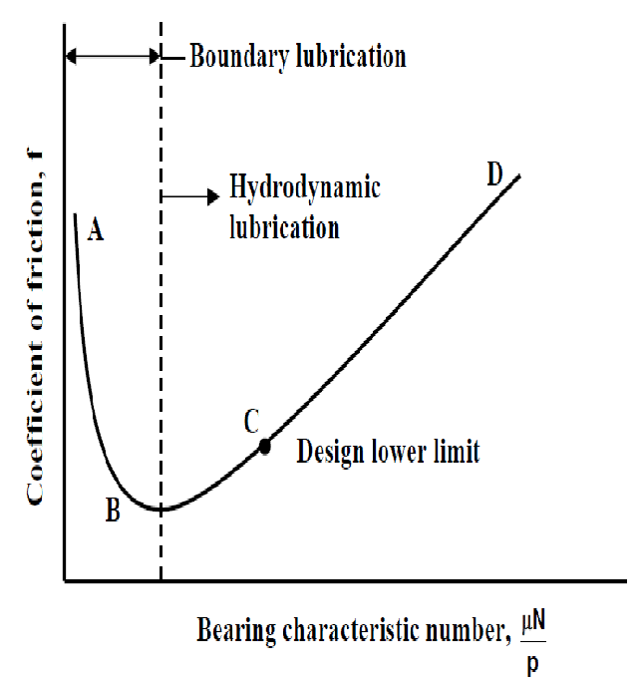

Heat Generated (Q_{g}):
Q_{g} = f U = μ N U = μ W U, Where N = Reaction of force, Surface velocity U = (πd N)/60
Heat Dissipated (Q_{d}):
Q_{d} = C_{d} A_{p} ΔT
Here, T_{o} = Oil temperature,
T_{b} = Bearing Temperature = (T_{b}+T∞)/2,
T∞ = Surrounding temperature,
ΔT = (T_{b}-T∞)/2 = (T_{o}-T∞)/2,
C_{d} = Dissipative heat transfer coefficient.
A_{p} = Projected area of the bearing = D_{o}l = Dl (neglecting thickness of bearing) = dl (neglecting clearance)
= KA_{j}, Where A_{j} = Area of Journal, K = Real Number (Area neglecting coefficient)
If Q_{g} > Q_{d} , External cooling is required.
Cooling required Q_{c} = Q_{g} - Q_{d}

